August 9, 2022 – Carson Valley Photo Club Meeting Minutes

Attendees
Susie Roaldson
NJ Thompson
Donald Swezey
Robin Grueninger
Bob Fores
Sandy Jonkey
Sandra Silva
Sherri McGee
Tom Monti
Joe Clements
Kimberly Burchiel
Dave Arstein
Sandra Branton
Nancy Hulsey
Tami Force
Jackie Gorton
Jean Desilets

Aaron Harris – guest speaker
Beth Enos – photo contest judge

Guest Speaker Aaron Harris
Astro photography / night photography
Aaronharrisphotography.com (during his talk, I grabbed screen grabs, you can see all his shots and more on his website)

Recently moved down here from Bend, Oregon. Lived up there for many years. Did a bit of action photography, kids were skateboarders. Got into photographing professional mountain bike riders. Ended up getting published in Mountain Bike Action. Started shooting models and product for a sports clothing company. Did some real estate photography. Relocated about 11 months ago. Wanted to be closer to his dad. Has a job working for Action Camera and is teaching classes for them, lighting, astro photography. The desert landscape is different.

Essential Equipment

Need a steady solid tripod with some kind of trigger like a timer on your camera or a cable release. Just the slightest touch can ruin the shot.

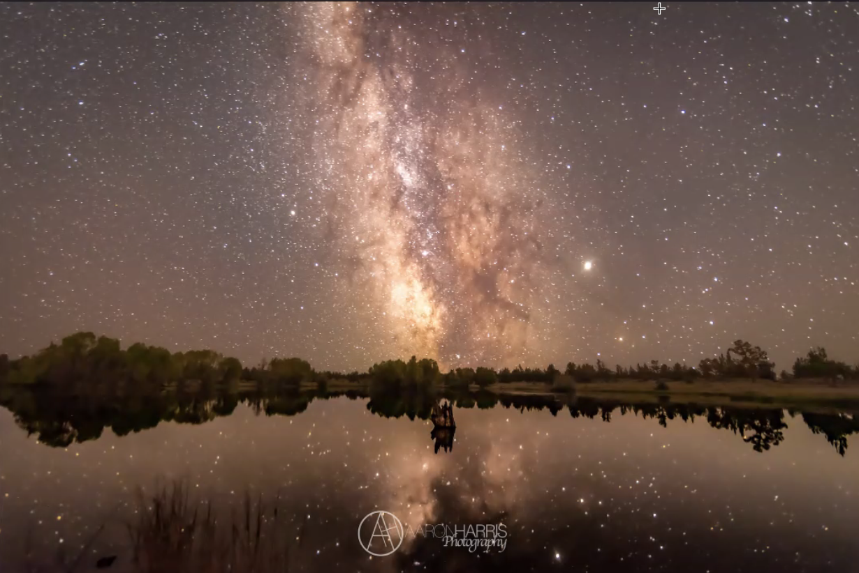
23-24 second, 14-15mm, ISO 4,000-6,000
This was probably late July, beginning of August, right outside of Bend, Oregon. Bend was to his right. You need to be pointing southeast direction to shoot the milky way. Getting night sky reflections in the water are fun and creative. Doesn’t have to be the full milky way.

A wide angle lens is a needed for good night sky shooting, the formula used to be the 500 rule that has since changed to the 400 rule. If you take the mm width of your lens, and divide by 400 that will give you the amount of seconds you can leave your shutter open before seeing a trail. The formula says you could use a max 28 second exposure with a 14mm lens before seeing star trails.

Some tips:
- 20mm 1.8 prime is the lens people go to for astro photography
- Don’t want to be any narrower than 24mm
- Use no more than 2.8 aperture.
- 16-35mm is great for wide landscape that can be used.
- Always shoot with your lens wide. You need infinity focus, and do not just use the setting. You need to use manual focus to dial it in and get sharp stars. Focus is one of the hardest challenges.
- On mirrorless cameras, you can increase the ISO really high like 24,000, and zoom in to focus better on the stars using the live view.
- Some people will use electrical tape to mark the focus so the lens won’t move out of focus.
- Hyperfocal distance, near and far.
  - Links to discussion on hyperfocal distance:
    - https://digital-photography-school.com/how-to-find-and-use-hyperfocal-distance-for-sharp-backgrounds/
    - https://www.cambridgeincolour.com/tutorials/hyperfocal-distance.htm

- PhotoPills, an app where you can plug in your lens and it will show you details. The app will also show you when the stars are best for viewing. For August 20, Photo Pills says moon will rise at 12:08am and it will set at 3:35pm, 9:24pm galactic core becomes visible and ends at 1:03am. That means good shooting starts at 9:24pm. (PhotoPills is about $10.99 in the App Store. (iPhone))
- He usually shoots around 4,000-6,000 ISO on his full frame camera. Crop sensors have less ability.
- When you start really post processing, you will use stacking and shooting really high ISO, using Topaz.

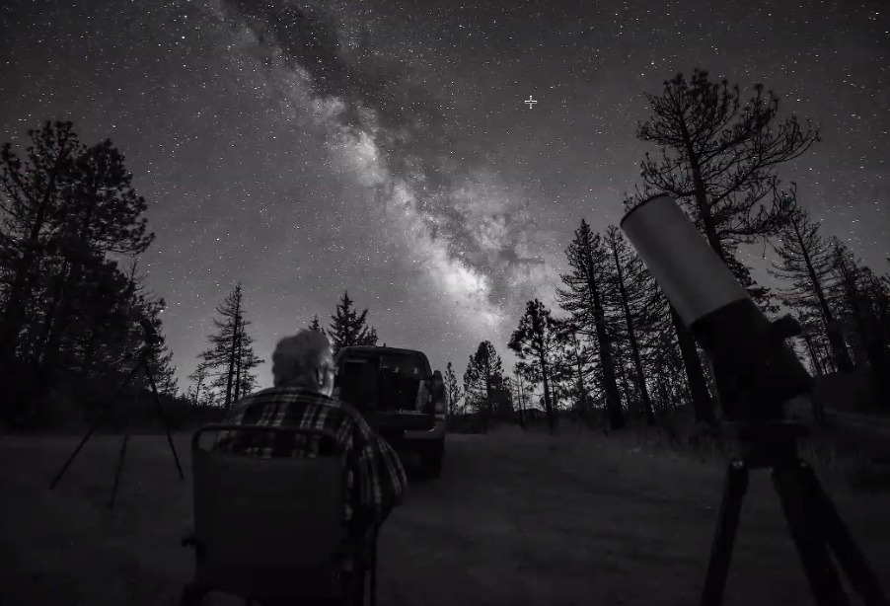
His dad is an astronomer.

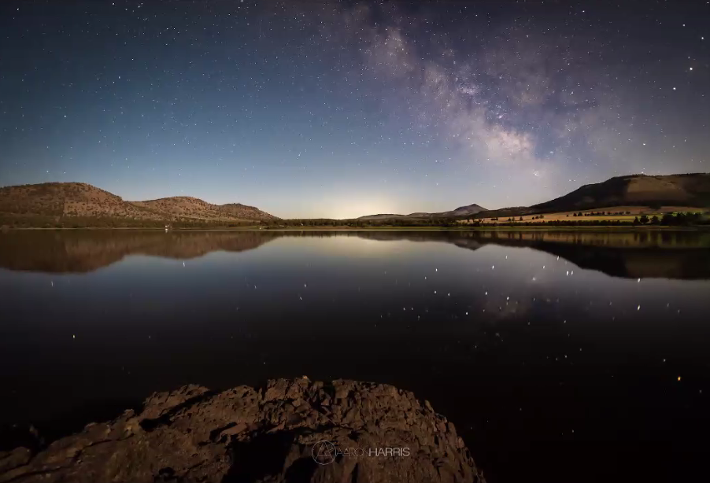
Had the moon at his back. Best to avoid the moon so it doesn’t wash out the stars.

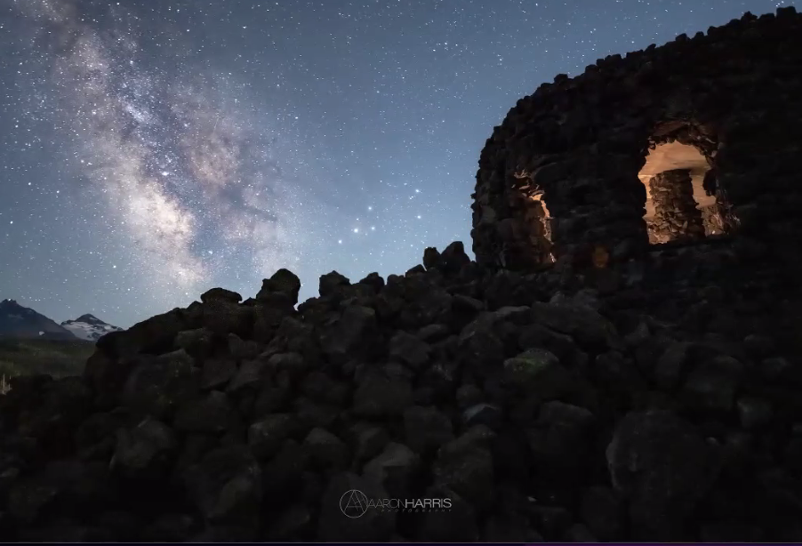
He lighted the cave (D Wright observatory) to give interest to the foreground. 30-40 mins out of Bend.

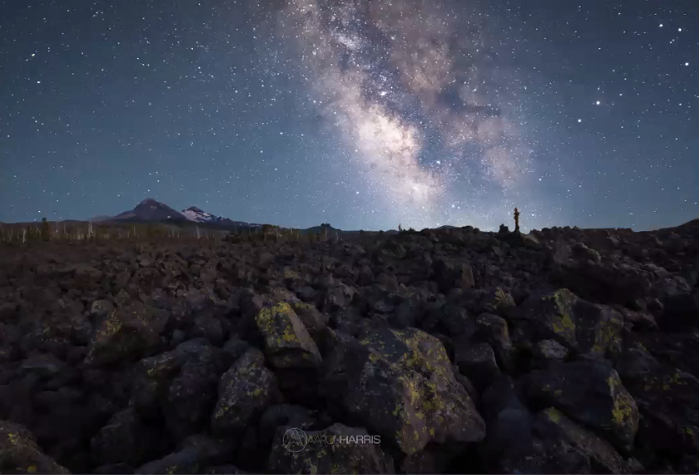

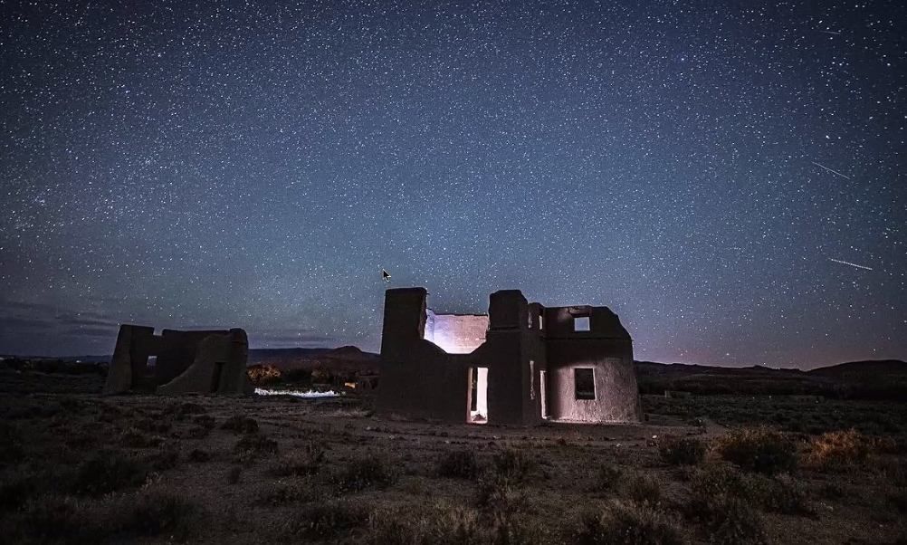
Didn’t have any galactic core here, but lighted the building and did a long exposure to get the sky.

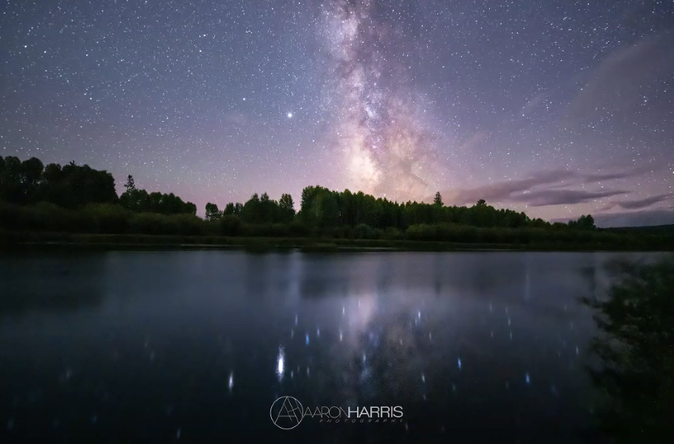
Clouds can add to the image.

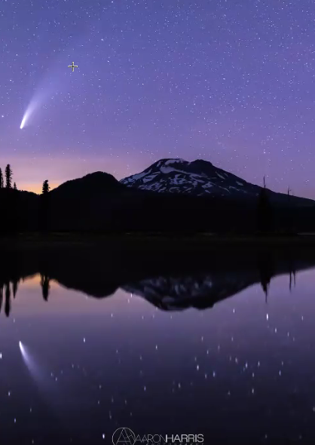
Captured the comet. 3,200 ISO, 23-24 second, 14-15mm, 2.8 aperture (wide open).

You will get to know what you can do in post processing. When you are shooting in raw, you have the ability to capture some details to help bring the picture together.

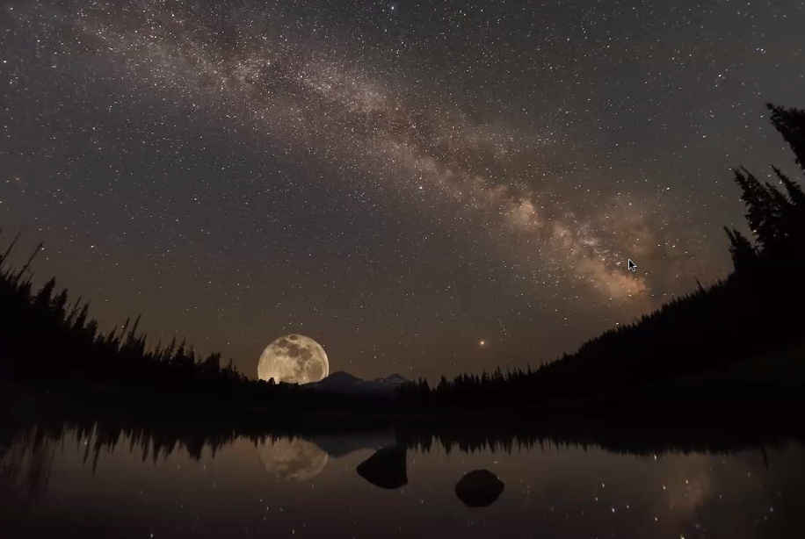
This is a built shot off of a couple of his shots, moon was one shot then added the stars.

More tips:
- He has a Rokinon 12mm lens, really affordable and works really well. Does have some bend in the lens. Rokinon makes a 14mm lens that has less distortion.
- Start by using 8,000 to 16,000 ISO, see what you get. With mirrorless, you can probably shoot way higher.
- Shooting stars over water is neat, builds a different dimension.
- Starry Night Stacker in the Appstore – import your shots in and it will auto align the shots, stacks them and reduces the noise.
- Topaz Labs AI Denoise is phenomenal in removing noise.
- Remember that your long exposure shots will start to generate heat and then that adds color noise that may need to be removed.
- Shorter exposure times allow you to take more photos and stack them to reduce the amount of noise.
- Take head lamps with you, the ones with a red light are better, especially if you are in a group.
- Know where the buttons are on your camera because you will be in the dark.
- Walking sticks are super important so you don’t stumble with your gear in a backpack.
- Good hiking books are helpful, you may run into dew, need good traction.
- Dress warm because it can cool off really quick.

Night Field Trip
Saturday Aug 20 seems to work the best for those that have responded to Susie.
Thinking about Hope Valley, where 88 and 89 meet.
Best shooting starts at 9:24pm.
Meet at the south end of the Douglas County High School, across from the swim center at 7:30pm.
More details to come.

Barn Photo Trip
August 28, Sunday morning, 2 barns set up right now.
More info coming soon.

Copeland Gallery Show Opening
Went really well.
Big thank you to Kim Steed.

Next Month’s Meeting
Sept 13
Tami will speak about ghost towns and historical photo trips/locations

August Photo Contest – Hometown Pride

Judge: Beth Enos

Judging Comments:
Likes to give a few summary points of what she finds important. The theme Hometown Pride is open to so many interpretations. Critiquing photos is tough to do. Just saying a photo is good is not good enough. Nobody would stretch their skills. It’s an effort to become a better photographer.

Good photos aren’t just taken, they are created. You plan and think about it. What is the best time of day? Where are shadows and light going to be? What depth of field? Spontaneity is fun but doesn’t make for best photos.

Noon is not your best option for trying to catch details and textures. Best to go out before dawn or right at the end of the day. Will get the best light and reflections then. Photography is about capturing the light. Remember all the things to look for beyond your subject. Can you see the details?

Maintain your equipment. Dust on your sensor can be easily removed if you keep your sensor clean. If you have a sky without a cloud, limit how much you put in your image. All it does is take up space and its negative space if it has no clouds.

She uses the term “white horse” or hero. What is the subject, the creative focus of the image?

Images were great. Simplify, watch your crop, check your view finder before you take the photo to exclude/include the right subjects.

#1 Sierra Reflections in the Spring Stream – Sharp, great saturation, beautiful scene. Suggestions, focus appears to be lower righthand corner. The rest of the image is soft. Maybe be careful about the lens you use and the focal plane you use and the focus of your image. Appears to be late morning with sun overhead. Not a lot of detail in mountains or grassland. Sun take detail away from photo and leaves it kind of flat.

#2 Nevada Wildlife – Wants to love this photo. It’s sharp, a great catch of this moment of time. Appreciates the magpie being part of the energy but it is a distraction along with the grass. It could be cropped out. Would move the eagle to have it sit on the left side of the image. Could switch up your depth of field so the water is less sharp and bring more focus to the bird and catch of the day.

#3 Nevada’s Family Events – This tells a story. There’s enough of the balloon to tell what’s going on. The family is out of the shadows. There’s action, life, and story. Likes this a lot. Great photo. It’s family, it’s hometown pride. Good shot!

#4 Wind Blown Cloud Layers above the Sierras – Sunsets can be a bit of a gamble. Camera doesn’t see things like you see them. Your capture is a slice. Doesn’t have the color range that your vision does. Energy, emotion and excitement doesn’t pass on as well as we’d hope. Bright color does not make an amazing photo. There needs to be more to carry it through.

#5 Bully Boy – The guy is awesome. Would love to see more texture in his physicality. Overcast sky hinders that detail and definition. Would potentially choose a different depth of field, blur the back. Farm isn’t necessary. The sensor is dirty. You could take those out in post processing.

#6 Nevada’s Wild Horses – Very nice. The light catches the animals from the side. You have catch lights on their heads separating them from their background. Crop is very nice. There is motion. You see texture in their coats, lots of detail that tells a story. The dust kicking up, the tail. It’s fun and energy.

#7 Carson Valley Plain – Nice capture of the valley. Confused about what the subject is. Maybe the group of buildings in the lower part of the image. Not sure what story it is telling. More is not always better. It is helpful to simplify and not try to create epic images. The story is in a smaller piece.

#8 Carson Artistry – This is really interesting. It’s a little confusing. Where is the focus on the image. The focus is on the lamp. Horse should have been in focus.

#9 Gorgeous Sierras and Green Fields – Almost similar to the first photo we looked at. It is an expected photograph. It has been take over and over. That’s not a negative. The clouds have taken away the details. The rest is not sharp. Not sure what the subject is. Is it the water, cattle? It has a great sky.

#10 Mustangs and Wideopen Range – Good capture of the wild horses in this vast area, but what is the subject? The background? The horses below? The horse on the left? Pick a subject. Understand the idea is to capture the vastness of the space, but that is difficult to do. There is too much information in the shot.

#11 Ice Water Pasture – Might be helpful to warm up the image. The mountains are very cool. If the image was warmed up a bit, the foreground might bring you in more, the tree and fence line. What you see is the ice and the mountains. Challenging to find the story. Not much detail in the mountains. The tree and to the right of the tree seem to be the most in focus. Important to know your plane of focus.

#12 Lost of History – The first thing she see is the dust spot on the sensor right above the barn near the center. Should clean that up in post processing. Think about learning how to spot dust in your images. Appears to be taken mid-day, sun takes away all the detail and interest. It looks flat. Would be better with some life in the image, like an old truck. Might also think about a different crop to take away some of the sky, there is too much of it and there is not energy or drama in the sky.

#13 Serene Balloon – It’s a great balloon. It’s part of life in the Carson Valley, but it’s one balloon in the middle of a big, dead sky. Maybe a different crop, like a panoramic and take away most of the sky.

#14 Who Me? – What’s the subject? The dark horse’s rump stands out most. Move to the left a little bit, simplify, adjust your perspective and limit the subject. Focus in on the guy looking right at us. Maybe a different crop would help to single out 1 or 2 subjects and be more specific in what you choose as a hero. Love the idea of wild horses, but being able to separate 1 or 2 would be helpful here.

#15 DSC_4170 – This is a great catch of the deer dueling. There is a lot of monotone dead space in the image. Either spend some time in post processing to create some definition in the deer to pull them off the background OR you could crop it down so you just get the duel of the deer, don’t even have to have the full deer. There is great energy in the activity between the 2 deer, but the rest of it is pretty even tone, not a lot of drama. Crop or zoom in. Timing of this one was awesome.

#16 TJs Corral, Song for America – Big attitude, hero, energy. This is a moment in time. Great capture. Love the subject, silhouette. Does not like the blob in the lower left corner. Check your view finder when you are taking the image. What is acceptable to be in the image. This would be her favorite top pick except for the blob.

#17 DSC_5687 – A little late in the morning to get the good light that would have given more detail. The mountains are pretty flat because of the light. The balloons are in the big old dead sky. This is one of those expected shots, done a lot. Not enough energy in the photo.

First Place: #3 Nevada’s Family Events – Don Swezey
Second Place: #6 Nevada’s Wild Horses – Don Swezey
Third Place: #16 TJs Corral, Song for America – Wendy Whyman

Honorable Mentions:
#2 Nevada Wildlife – Don Swezey

Winners please send a jpg to Nancy Hulsey full resolution photos (nancyhulseyphoto@aol.com).
And bring print to Robin at Marty’s Appliance. NJ will hang at library.

Contest Reminders:
Be careful of your photo being too large. Website can only take up to 25mb which is pretty large. Also, you need to properly name your shot before you upload it into dropbox.

Remember we have a deadline for the photos, midnight of the Tuesday a week before the meeting.

Thanks to those for participating! Next month’s contest (September) is Light Painting.

